**Signal Processing**

1. Understanding properties of Discrete Time Sinusoidal signals
   * + - 1. Plot the discrete time real sinusoidal signal 𝑥𝑛=10𝛽! for positive 𝐶 when,

𝛽<−1

**%code**

syms B;

B = -5;

% B = -0.5;

% B = 0.5;

% B = 5;

n = 0:1:10;

x = 10*B.^n;

stem(n, x);

grid;

**%output**

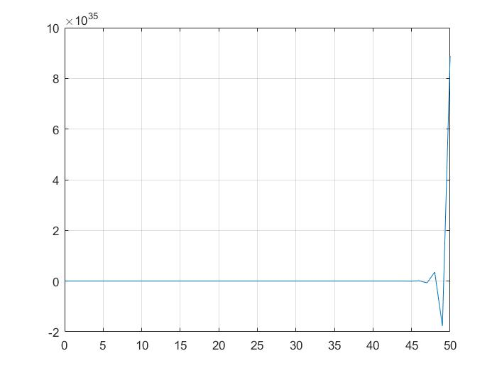

 −1<𝛽<0

**%code**

syms B;

% B = -5;

B = -0.5;

% B = 0.5;

% B = 5;

n = 0:1:10;

x = 10*B.^n;

stem(n, x);

grid;

**%output**

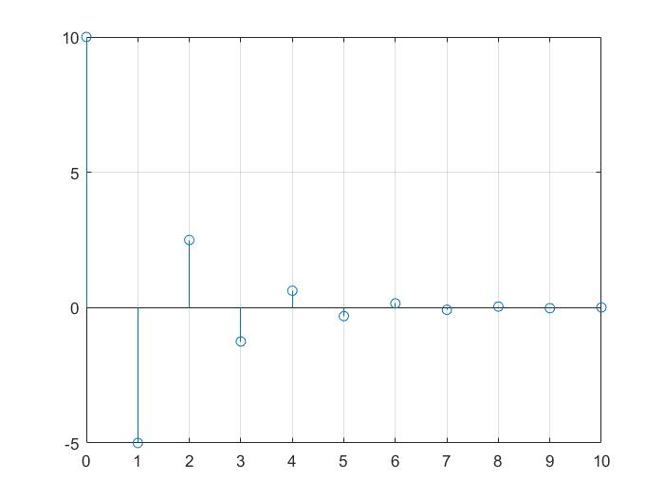

0<𝛽<1

**%code**

syms B;

% B = -5;

% B = -0.5;

B = 0.5;

% B = 5;

n = 0:1:10;

x = 10*B.^n;

stem(n, x);

grid;

**%output**

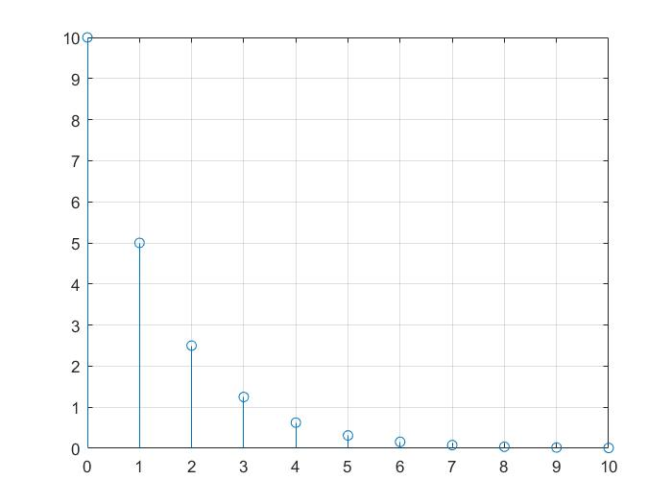

𝛽>1

**%code**

syms B;

% B = -5;

% B = -0.5;

% B = 0.5;

B = 5;

n = 0:1:10;

x = 10*B.^n;

stem(n, x);

grid;

**%output**

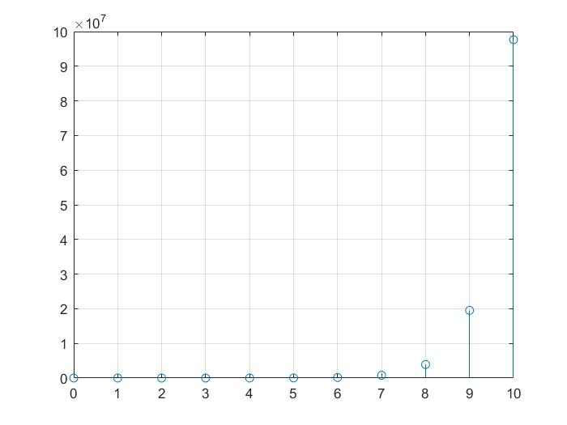

* + - * 1. **Plot 𝑥𝑛 and 𝑥(𝑡) in the same plot for the following sinusoidal signals. Let 𝑛=𝑘𝑇 where 𝑇=5𝑠  and 𝑘∈𝑍. That is 𝑥[𝑛] is obtained by sampling 𝑥[𝑡] at every 5 seconds. Determine the  theoretical fundamental period of each signal**

$X\left[n\right]=\cos\left(\frac{2πn}{12}\right), x\left[t\right]= \cos{(\frac{2πt}{12})}$

**%code**

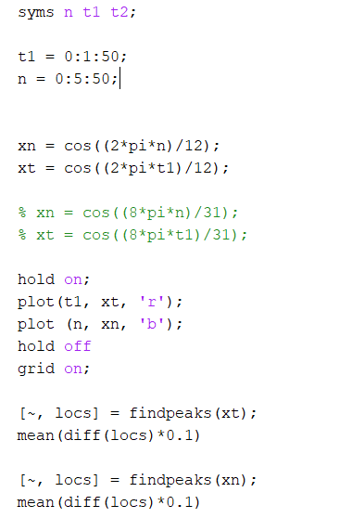

**%output**

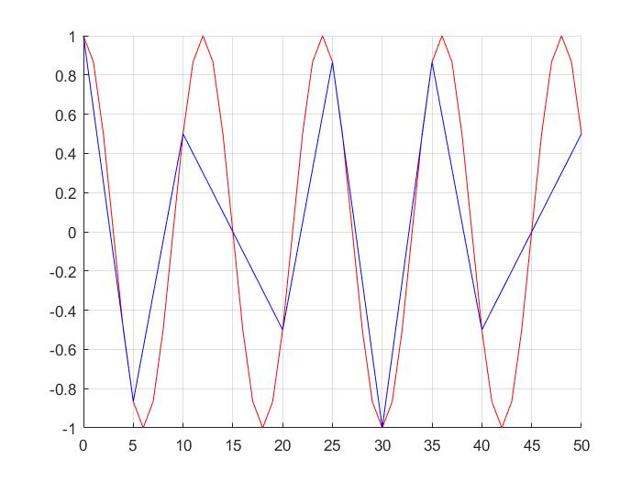

**Theoretical fundamental period of xn = 0.2500**

**Theoretical fundamental period of xt = 1.2000**

$X\left[n\right]=\cos\left(\frac{8πn}{31}\right), x\left[t\right]= \cos{(\frac{8πt}{31})}$

**%code**

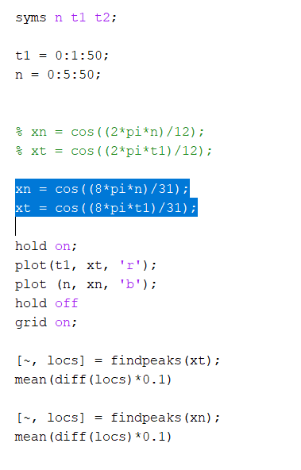

**%output**

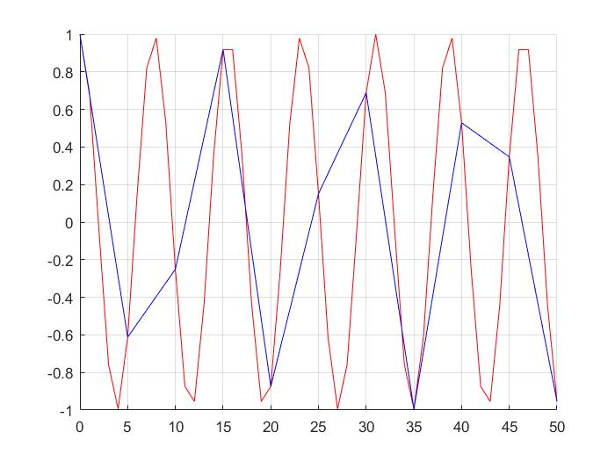

**Theoretical fundamental period of xn = 0.2500**

**Theoretical fundamental period of xt = 0.7800**

**Is the observed period of the signal from the plot always equal to the theoretical period?**

**No it doesn’t, it varies with the time**

* + - * 1. **Plot the following nine discrete time signals in the same graph**

$X\left[n\right]=\cos\left(0.n\right)$

$X\left[n\right]=\cos\left(\frac{πn}{8}\right)$

$X\left[n\right]=\cos\left(\frac{πn}{4}\right)$

$X\left[n\right]=\cos\left(\frac{πn}{2}\right)$

$X\left[n\right]=\cos\left(πn\right)$

$X\left[n\right]=\cos\left(\frac{3πn}{2}\right)$

$X\left[n\right]=\cos\left(\frac{7πn}{4}\right)$

$X\left[n\right]=\cos\left(\frac{15πn}{8}\right)$

$X\left[n\right]=\cos\left(2πn\right)$

**%code**

syms n;

n = 0:1:20;

x1 = cos(0*n);

x2 = cos(pi*n/8);

x3 = cos(pi*n/4);

x4 = cos(pi*n/2);

x5 = cos(pi*n);

x6 = cos(3*pi*n/2);

x7 = cos(7*pi*n/4);

x8 = cos(15*pi*n/8);

x9 = cos(2*pi*n);

subplot(3,3,1);

plot(n, x1);

title('x[n] = cos(0.n)');

xlabel('0 <= n <= 20');

ylabel('x1');

subplot(3,3,2);

plot(n, x2);

title('x[n] = cos(pi*n/8)');

xlabel('0 <= n <= 20');

ylabel('x2');

subplot(3,3,3);

plot(n, x3);

title('x[n] = cos(pi*n/4)');

xlabel('0 <= n <= 20');

ylabel('x3');

subplot(3,3,4);

plot(n, x4);

title('x[n] = cos(pi*n/2)');

xlabel('0 <= n <= 100');

ylabel('x4');

subplot(3,3,5);

plot(n, x5);

title('x[n] = cos(pi*n)');

xlabel('0 <= n <= 20');

ylabel('x5');

subplot(3,3,6);

plot(n, x6);

title('x[n] = cos(3*pi*n/2)');

xlabel('0 <= n < =100');

ylabel('x6');

subplot(3,3,7);

plot(n, x7);

title('x[n] = cos(7*pi*n/4)');

xlabel('0 <= n <= 20');

ylabel('x7');

subplot(3,3,8);

plot(n, x8);

title('x[n] = cos(15*pi*n/8)');

xlabel('0 <= n <= 100');

ylabel('x8');

subplot(3,3,9);

plot(n, x9);

title('x[n] = cos(2*pi*n)');

xlabel('0 <= n <= 21');

ylabel('x9');

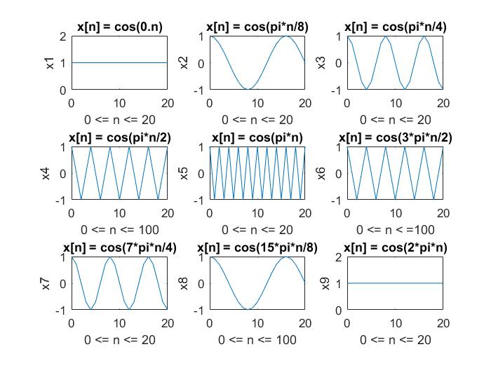**%output**

* + - * 1. **By observing the plots, you have obtained in question 1.c, what can you tell about the shape of the signal as discrete frequency is varied?**

**As the frequency increased the circularity of the graph also increased, more like becoming a continuous signal.**

1. **Discrete convolution**
   1. **write a matlab function to implement discrete convolution for 𝑛>0. Note that 𝑦𝑛=𝑥𝑛∗ℎ𝑛 is given by  the convolution summation 𝑦𝑛= 𝑥𝑘ℎ[𝑛−𝑘]**

**%code**

function y = convolution(x,h)

m=length(x);

n=length(h);

X=[x,zeros(1,n)];

H=[h,zeros(1,m)];

for i=1:n+m-1

y(i)=0;

for j=1:m

if(i-j+1>0)

y(i)=y(i)+X(j)*H(i-j+1);

else

end

end

end

end

* 1. **Using the function written in section a, convolue x[n] = 0.5nu(n) with h[n] = u[n]. Plot the output signal along with the two input signals.**

**%code**

n = [1,2,3,4,5];

un = [1,2,3,4,5];

hn = un;

xn = 0.5 .^n .* un;

y = convolution(x,h);

subplot(3,1,1);

stem(xn);

grid

xlabel( 'n' ) ;

ylabel( 'x(n)' ) ;

subplot(3,1,2);

stem(hn);

grid

xlabel( 'n' ) ;

ylabel( 'h(n)' ) ;

subplot(3,1,3);

stem(y);

grid

xlabel( 'n' ) ;

ylabel( 'y(n)' ) ;

function y = convolution(xn,hn)

m=length(x);

n=length(h);

X=[x,zeros(1,n)];

H=[h,zeros(1,m)];

for i=1:n+m-1

y(i)=0;

for j=1:m

if(i-j+1>0)

y(i)=y(i)+X(j)*H(i-j+1);

else

end

end

end

end

**%output**

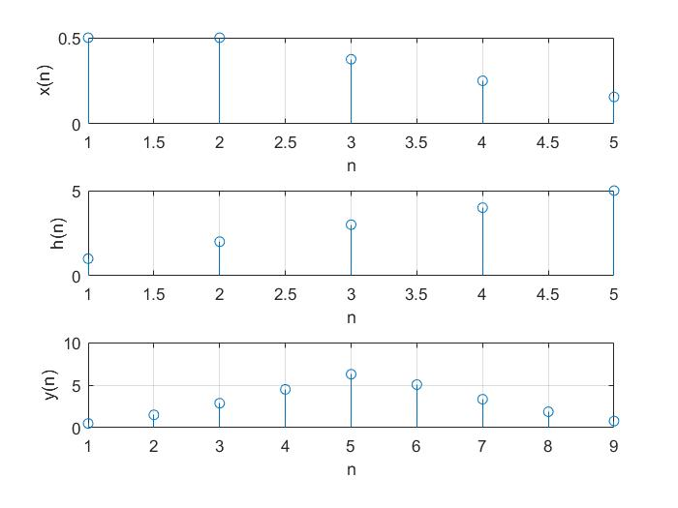

**Consider the following two signals x[n] = [1 1 1 1 1 0 0 0 0 0 0 0 0 0 0], h[n] = [ 2 4 8 16 32 64 0 0 0 0 0 0 0 0 0 ]**

* + 1. **Convolue the two signals using the function written in part a. Use matlab conv command to verify your answer**

**%code**

xn = [1,1,1,1,1,0,0,0,0,0,0,0,0,0,0];

hn = [2,4,8,16,32,64,0,0,0,0,0,0,0,0,0];

y = convolution(xn,hn)

y_1 = conv(xn,hn)

function y = convolution(x,h)

m=length(x);

n=length(h);

X=[x,zeros(1,n)];

H=[h,zeros(1,m)];

for i=1:n+m-1

y(i)=0;

for j=1:m

if(i-j+1>0)

y(i)=y(i)+X(j)*H(i-j+1);

else

end

end

end

end

**%output**

**y =**

**Columns 1 through 10**

**2 6 14 30 62 124 120 112 96 64**

**Columns 11 through 20**

**0 0 0 0 0 0 0 0 0 0**

**Columns 21 through 29**

**0 0 0 0 0 0 0 0 0**

**y_1 =**

**Columns 1 through 10**

**2 6 14 30 62 124 120 112 96 64**

**Columns 11 through 20**

**0 0 0 0 0 0 0 0 0 0**

**Columns 21 through 29**

**0 0 0 0 0 0 0 0 0**

* + 1. 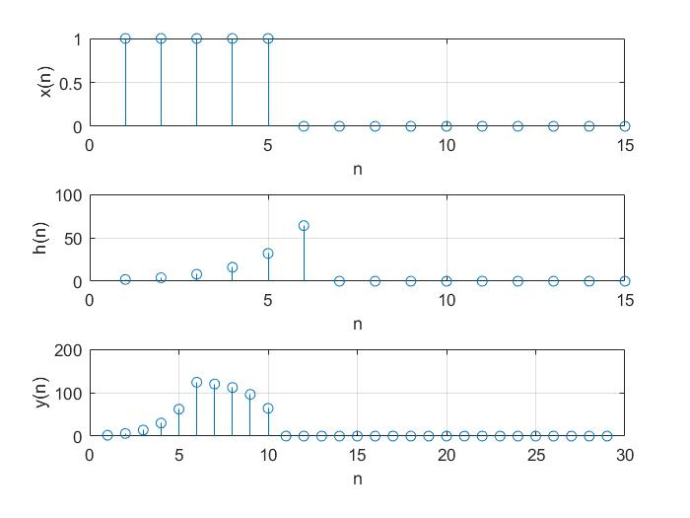**Consider the shape of the signal h[n] and the output signal, what sort of a transformation has been applied through the convolution operation?**

1. **LTI Systems**
   1. **Consider the following processes. Identify input x[n] and output y[n] for each case. Implement a matlab function to implement the given system.**
      1. **An investor is maintaining a bank account. The bank pays him a monthly interest of 1%. It is given that the net savings he makes is P. Write a function to calculate his current bank balance B in terms of B and P.**

function B = interest(P)

B = P + P /100;

end

* + 1. **A merchant earns M amount of money monthly. He spends half of it and retains the rest of its as savings. Write a function to calculate the amount of money he has as savings**

function S = saving_balance(M)

S = M / 2;

end

* 1. **Find the impulse response of the above two LTI systems.**

P = 100000;

B = interest(P)

x = conv(B,P)

stem(x)

function B = interest(P)

B = P + P /100;

End



M = 100000;

S = saving_balance(M)

x = conv(S,M)

stem(x)

function S = saving_balance(M)

S = M / 2;

end

* 1. **Based on the results obtains at part b, classify two LTI systems into IIR or FIR**

The two LTI systems have finite impulse response. If the impulse response of the system is finite, it’s a FIR system (Finite Impulse Response). But if the impulse response is infinite it’s a IIR system (Infinite Impulse Response). Therefore both the LTI systems are FIR systems.